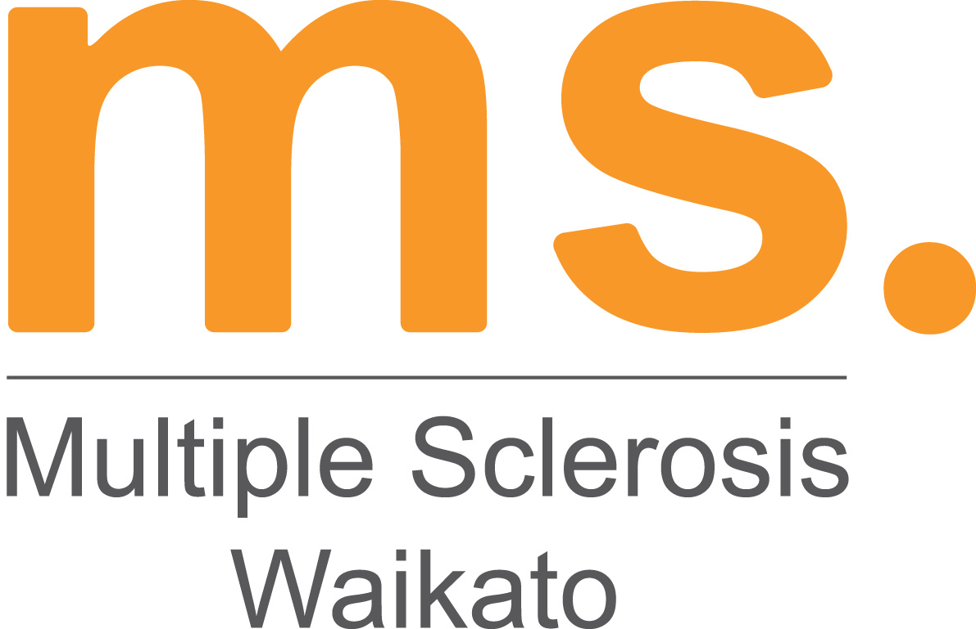

Welcome to MS Waikato

MS Waikato is a charitable trust providing support services to people affected by Multiple Sclerosis, Huntington’s Disease, and allied neurological conditions.

Our services include support for newly diagnosed and newly unwell clients including home visits, education sessions, advocacy, support groups, exercise classes, quarterly newsletters, carer support, lending library and website.

We need your support too. Your contribution in paying subscriptions helps ensure we are able to continue to provide these services. At this point in time you may not feel you need our services, however your support ensures we are here if yours or your loved ones situation changes.

----------------------------------------------------------------------------------------------------

MS Waikato Trust – Subscriptions and Donations

Name: _______________________________________________________

Address: _______________________________________________________

_______________________________________________________

Email address: ______________________________________________

Please tick if you prefer to receive the newsletter by email ______

Membership - $40, or with a Community Services Card - $20 $________

- Please tick if you have a community services card _____

Donation $________

Total $________

Please tick if you require a receipt ________

Payment is to be made to the MS Waikato bank account, please remember to include your name together with subs or donation (as applicable) as a reference.

BNZ Account: 02 0316 0488196 000

Donations are tax deductible, a receipt will be given for any donations received.

Thank you for your support and helping to make a difference.

If you have any queries re subscriptions email janet@mswaikato.org.nz

